**AWS and GCP Sensor Integration**

Date worked: 07/16 to 07/18 (24 hrs), 07/22 to 07/26= (20 hrs), 07/28 to 07/30(12 hrs)

Summary of Tasks undertaken:

1. As per the last report, I was working on task synchronization for sending GPS and CO Sensor over the Google cloud with 3rd task implemented.
2. Web UI team suggested to consider AWS IoT cloud integration, so I started working integrating GPS with AWS IoT.
3. During Integration phase, I studied the sample AWS code for B-L475E-IOTA discovery kit. The sensor data is published using the AWS pub/sub topic and an AWS thing.
4. In the sample code🡪AWS🡪aws_subscribe_publish_sensor_values.c, the following code snippet take the values of sensors in char pointer “payload” from sensor_data.c to publish the data

**Sensor_data.c**

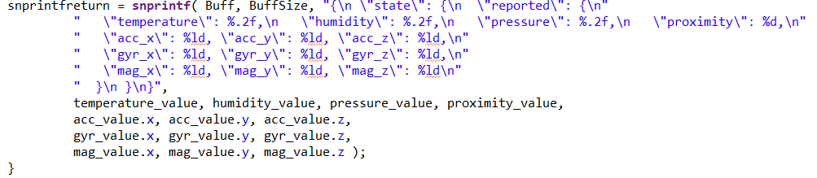

**aws_subscribe_publish_sensor_values.c**

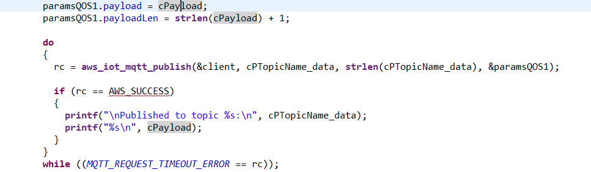

1. The aws_iot_mqtt_publish() publishes data on the AWS cloud, in order to include the GPS data in the payload we add the GPS logic in the code. GPS is connected to STM discovery kit on UART4 RX. In order to add the GPS logic we make the below modifications in main.c, aws_subscribe_publish_sensor_values.c, stmxx…msp.c, stmxx…it.c

**Main.c :** Add the below code snippet in main.c followed by HAL_UART_Receive_IT(&huart4, &gps_rx, 1); before cloud_test(0)

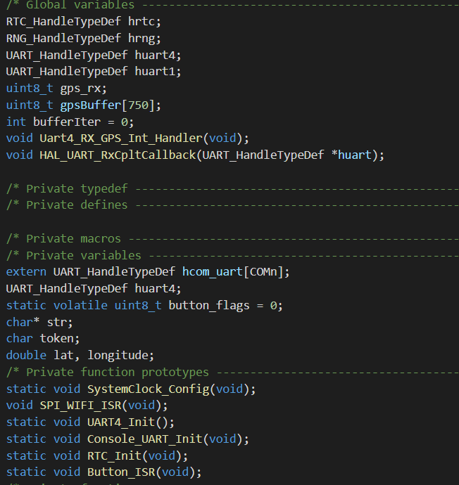

**Stmxx..msp.c and STMxx.._it.c:** At the end of the code, add the code for UART4 port initialization. Add UART4 interrupt code in stmxx_it.c

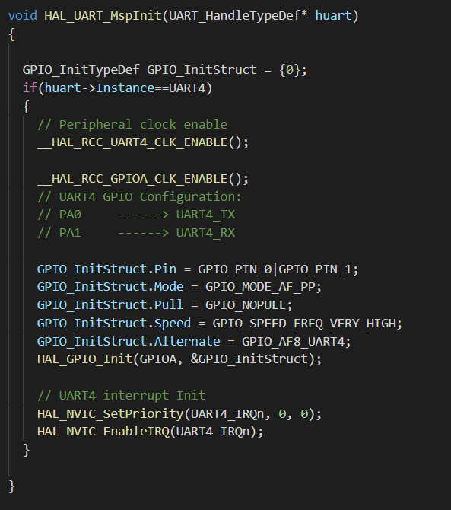

1. **From the previous report “GPS_CO_Sensor_FreeRTOS_Implementation”,** we need to add **HAL_Receive_IT(uart4)** indicating that when data comes at UART4, it will execute the interrupt routine where it calls UART4_Rx_GPS_Int_handler() to receive data and store in buffer (DMA approach)

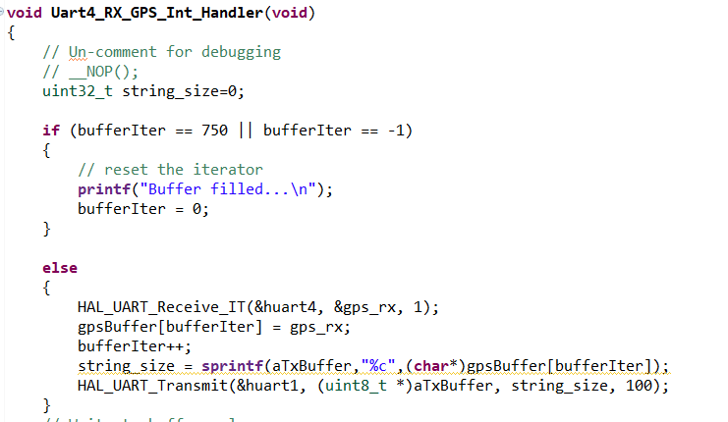

1. Once the code are added, add the gpsbuffer to the snprintf() code from sensor_data.c(figure from page 1), this will add the raw GPS data into the payload.

**Problem: After adding the raw GPS data with payload, AWS publish function was throwing an error: “payload data size is more than it can be published”. After digging around, I found that it cannot send entire raw gps data with the payload.**

**Solution:** It will be efficient to parse the GPS latitude and longitude data from the raw data. Due to time constraint, I looked online and got a C++ parsing code for GPS. It was able to extract the latitude and longitude data. Source for the code: <https://github.com/toskyRocker/Arduino_Parser_Ublox_Neo_M8N/blob/master/Parser_Ublox_Neo_M8N/Ublox.cpp>

**Problem: During initial build of sample AWS code, it was throwing the error that “It cannot load the bin file”**

**Solution:** I converted the code from release mode to debug mode by changing the build settings from .bin file to .hex file. It can be done as mentioned in the below screenshot

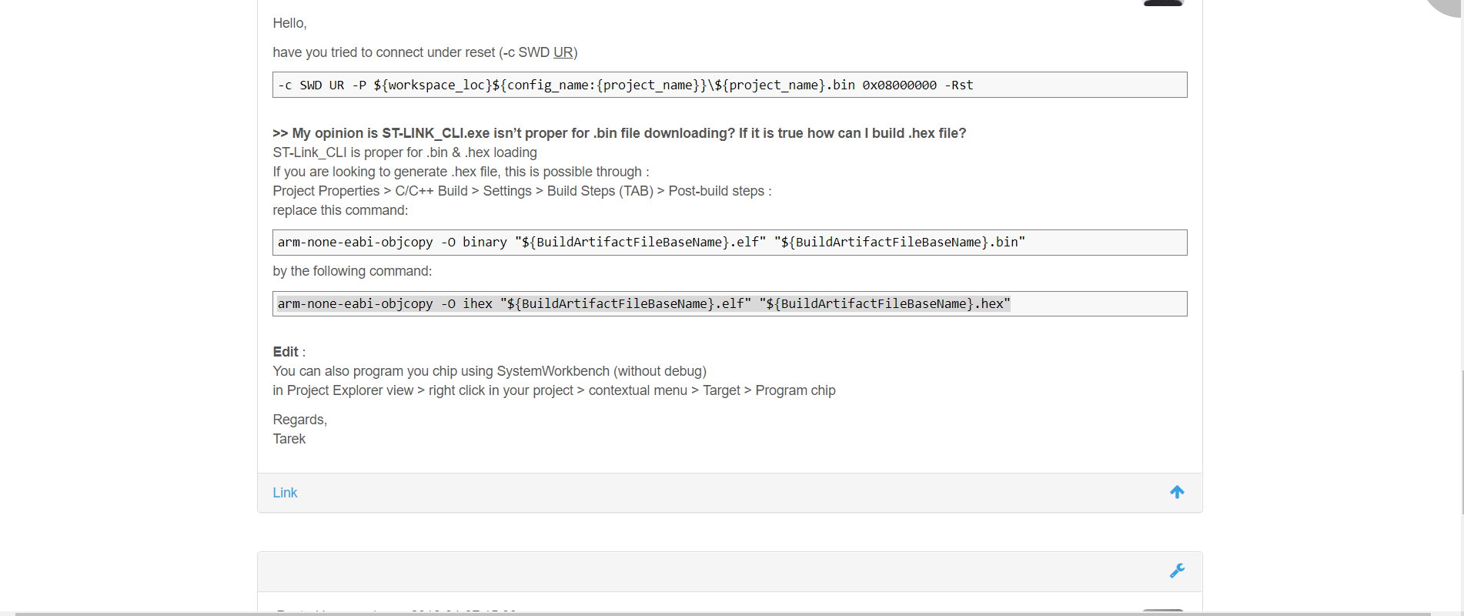

1. After adding the gps lat and gps long, the data was reflecting in the payload and the publish function was sending the data.

**Problem: My data is getting published, but it is not reflecting in AWS Cloud. It seems that previous jobs are getting queued as** **mentioned in screenshot below:**

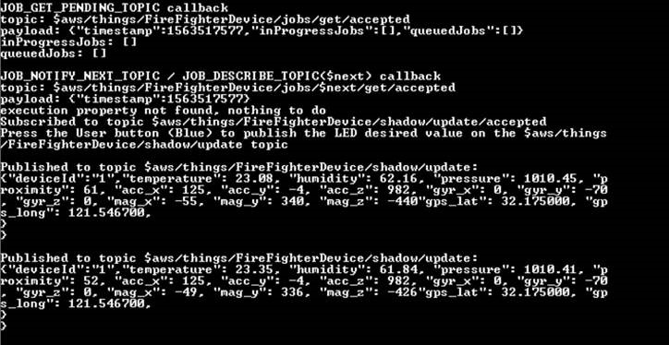

**Possible solution:** The JSON format to send the data seems incorrect. I am yet to test it with the discovery kit.

**GOOGLE CLOUD:**

* + - 1. It had to integrate my current GPS and GCP code with Web UI team’s google cloud. I took the following server address from Shikang. This server address links to Shikang’s google cloud from where he can extract the GPS data.

**“project-id=cmpe281-lab-218723;registry-id=firefighter;device-id=firefighter;cloud-region=us-central1”**

* + - 1. I added my Wifi credentials and added it to the configuration followed by the server address. I had to update the Root CA certificate and RSA256 private key.

**Problem: I updated the certificated and it was showing the following error: “**[**MBEDTLS_ERR_X509_INVALID_FORMAT**](https://tls.mbed.org/api/group__x509__module.html#ga45b8366804b7e2cbf3e25011f054802c)**-0x2180”**

**Solution:** I was updated the wrong key in Root CA certificate. I was adding the RSA256 public key as a Root CA. As per steps mentioned in [GCP user manual](https://www.st.com/content/ccc/resource/technical/document/user_manual/group1/e9/8a/9b/73/5c/ff/4d/10/DM00522079/files/DM00522079.pdf/jcr:content/translations/en.DM00522079.pdf) Section 5.5 (page 19), it clearly states as follows:

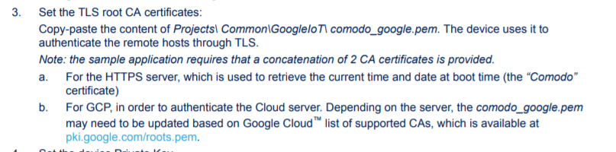

* + - 1. After updating the root CA certificate, it was able to connect to Shikang’s server and data was getting published in his google cloud. Since data is a raw GPS data, I shared the “index.js” file from Luke’s Github [link](https://github.com/lastjediluke/firefighterFinderGPS) for parsing GPS latitude and longitude data at the front end.

**Next Tasks**

I have to add CO sensor with Google cloud and integrate it with FreeRTOS. I can change the heap size from .ld file in the project. I am yet to test the change in code.

JSON format to send data to AWS file is incorrect. I need to modify it by taking help from Ramya (AWS cloud person).